Home Assignments
1) With vibe coding implement the playwright/typescript or any other tool which you work say Selenium/Python
2) Use Bugmagnet extension for form filling
3) Use grammarly extension to correct the mistakes in your content

2. Use Bugmagnet extension for form filling.
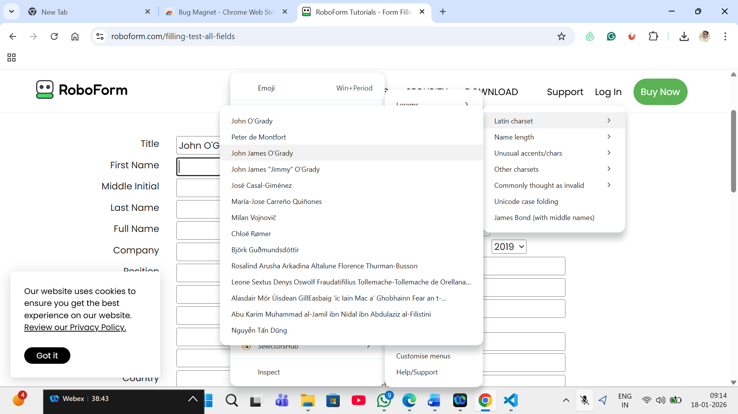
3) Use grammarly extension to correct the mistakes in your content

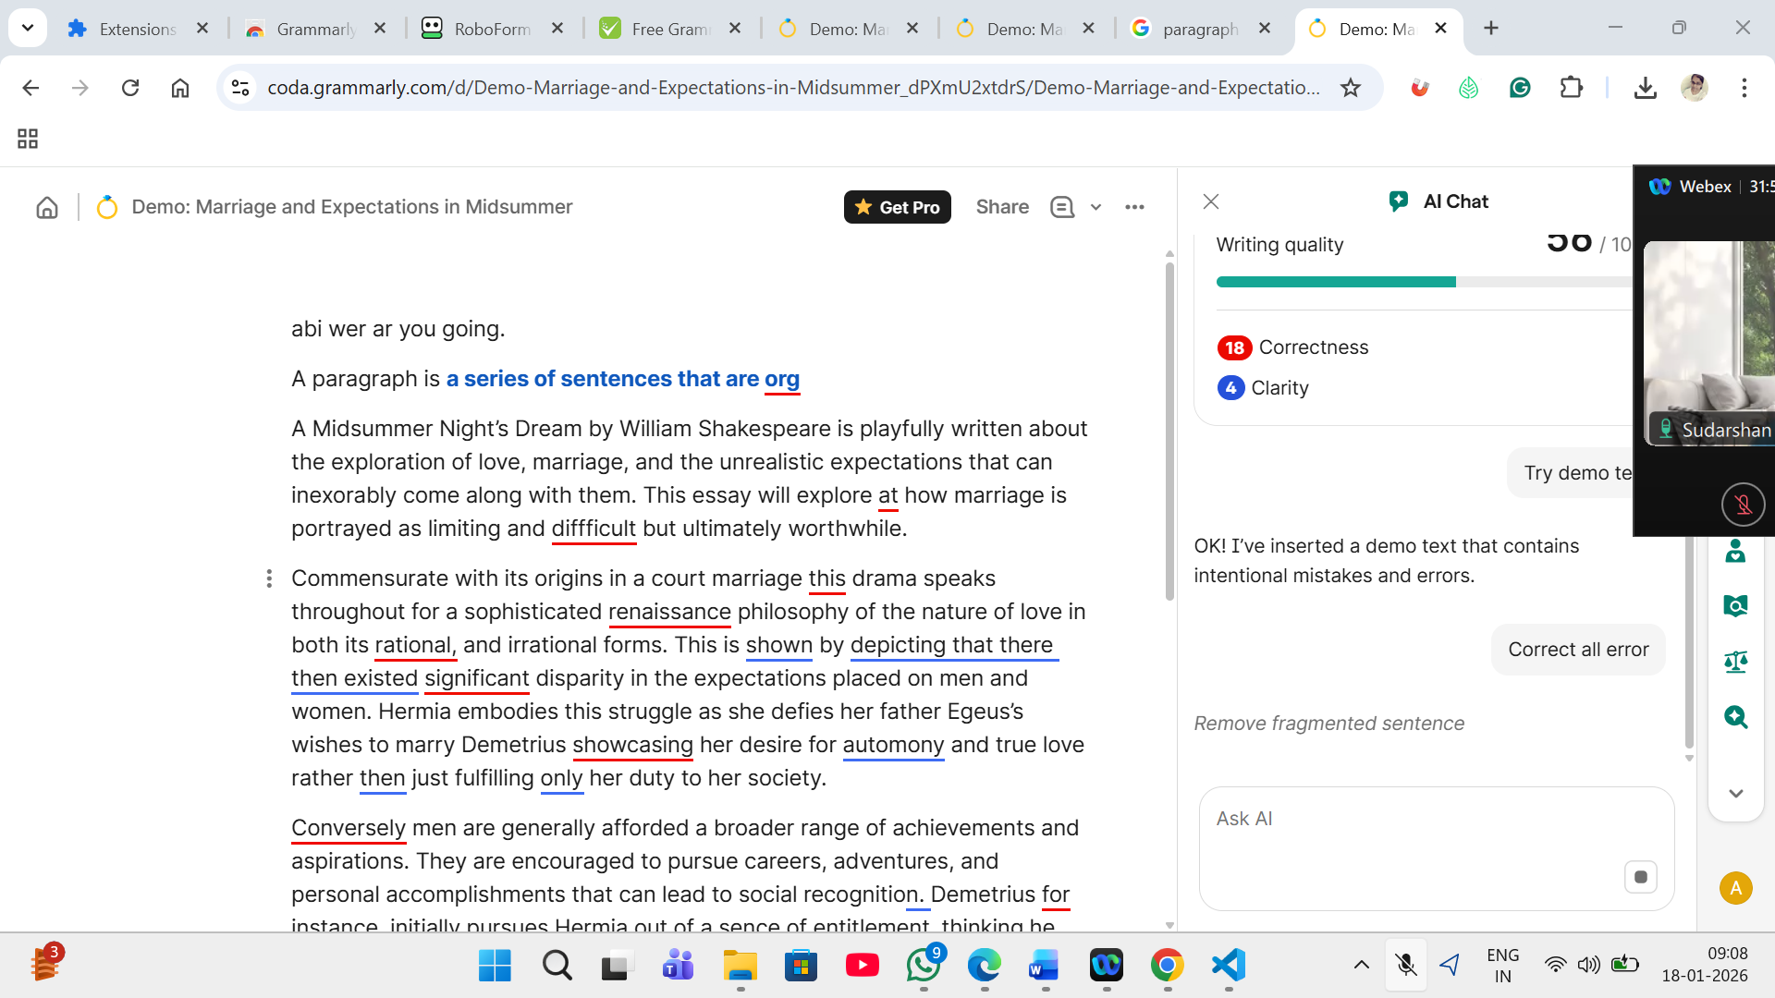
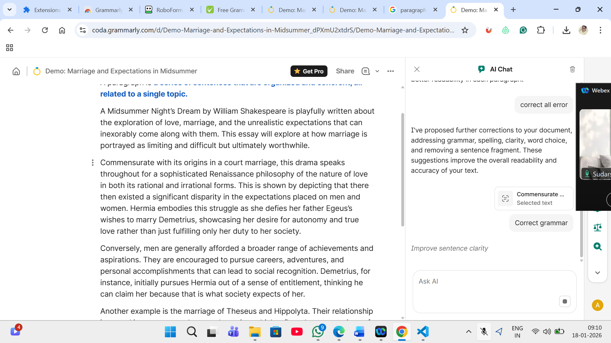
- With vibe coding implement the playwright/typescript or any other tool which you work say Selenium/Python
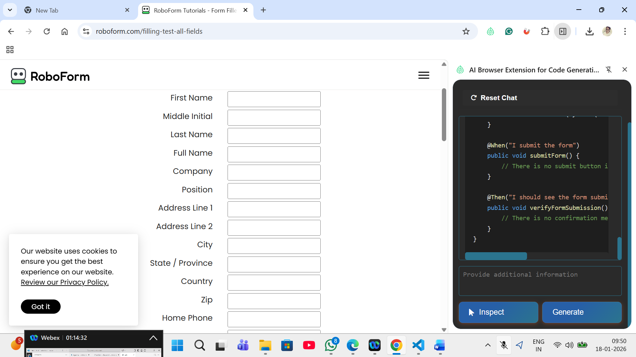
Code GeneratorSettings
Feature File Page Class
Reset Chat

Feature: Fill out the form with valid data

Scenario Outline: Successful form submission with valid credentials
Given I open the form page
When I fill out the form with the following details
| title | firstName | middleInitial | lastName | fullName | company | position | address1 | address2 | city | state | country | zip | homePhone | workPhone | fax | cellPhone | email | webSite |
| "<title>"| "<firstName>"| "<middleInitial>"| "<lastName>"| "<fullName>"| "<company>"| "<position>"| "<address1>"| "<address2>"| "<city>" | "<state>" | "<country>"| "<zip>" | "<homePhone>"| "<workPhone>"| "<fax>" | "<cellPhone>"| "<email>" | "<webSite>" |
And I submit the form
Then I should see the form submission confirmation

Examples:
| title | firstName | middleInitial | lastName | fullName | company | position | address1 | address2 | city | state | country | zip | homePhone | workPhone | fax | cellPhone | email | webSite |
| Mr. | Ramesh | K | Kumar | Ramesh Kumar | Infosys Ltd. | Manager | 123 Main St | Apt 101 | Bangalore | KA | India | 56001| 1234567890| 9876543210| 1111111111| 9999999999| ramesh@example.com| example.com |
| Ms. | Priya | S | Sharma | Priya Sharma | TCS Ltd. | Developer| 456 Park Ave | Apt 202 | Chennai | TN | India | 60001| 5555555555| 6666666666| 7777777777| 8888888888| priya@example.com| example2.com |

package com.leaftaps.stepdefs;

import io.cucumber.java.en.*;
import org.openqa.selenium.*;
import org.openqa.selenium.chrome.ChromeDriver;
import org.openqa.selenium.support.ui.*;

public class FormStepDefinitions {
private WebDriver driver;
private WebDriverWait wait;

@io.cucumber.java.Before
public void setUp() {
driver = new ChromeDriver();
wait = new WebDriverWait(driver, Duration.ofSeconds(10));
driver.manage().window().maximize();
}

@io.cucumber.java.After
public void tearDown() {
if (driver != null) driver.quit();
}

@Given("I open the form page")
public void openFormPage() {
driver.get("https://www.roboform.com/filling-test-all-fields");
}

@When("I fill out the form with the following details")
public void fillOutForm(DataTable dataTable) {
List<Map<String, String>> rows = dataTable.asMaps(String.class, String.class);
Map<String, String> data = rows.get(0);

driver.findElement(By.name("01___title")).sendKeys(data.get("title"));
driver.findElement(By.name("02frstname")).sendKeys(data.get("firstName"));
driver.findElement(By.name("03middle_i")).sendKeys(data.get("middleInitial"));
driver.findElement(By.name("04lastname")).sendKeys(data.get("lastName"));
driver.findElement(By.name("04fullname")).sendKeys(data.get("fullName"));
driver.findElement(By.name("05_company")).sendKeys(data.get("company"));
driver.findElement(By.name("06position")).sendKeys(data.get("position"));
driver.findElement(By.name("10address1")).sendKeys(data.get("address1"));
driver.findElement(By.name("11address2")).sendKeys(data.get("address2"));
driver.findElement(By.name("13adr_city")).sendKeys(data.get("city"));
driver.findElement(By.name("14adrstate")).sendKeys(data.get("state"));
driver.findElement(By.name("15_country")).sendKeys(data.get("country"));
driver.findElement(By.name("16addr_zip")).sendKeys(data.get("zip"));
driver.findElement(By.name("20homephon")).sendKeys(data.get("homePhone"));
driver.findElement(By.name("21workphon")).sendKeys(data.get("workPhone"));
driver.findElement(By.name("22faxphone")).sendKeys(data.get("fax"));
driver.findElement(By.name("23cellphon")).sendKeys(data.get("cellPhone"));
driver.findElement(By.name("24emailadr")).sendKeys(data.get("email"));
driver.findElement(By.name("25web_site")).sendKeys(data.get("webSite"));
}

@When("I submit the form")
public void submitForm() {
// There is no submit button in the provided HTML, so this step is skipped
}

@Then("I should see the form submission confirmation")
public void verifyFormSubmission() {
// There is no confirmation message in the provided HTML, so this step is skipped
}
}
Copy
InspectGenerate

